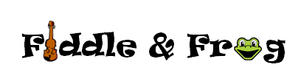

Fair Trade Charity List
* 10% of all proceeds from Fair Trade merchandise
at Fiddle & Frog are donated to charity! We’re pleased to support organizations that promote diversity and kindness and support folks and animals in our communities.

The Landing (Rochester, MN)
Camp Companion (Rochester, MN)
Diversity Council (Rochester, MN)
Ronald McDonald House (Rochester, MN)
Channel One Food Bank (Rochester, MN)
PossAbilities (Rochester, MN)
Ability Building Foundation (Rochester, MN)
Racine Food Shelf (Racine, MN)
World Literacy Foundation
Date | Fair Trade Sale Amount | Donated to…

